**Reversi Game Manual**

Starting the game:

1. Using the MARS editor, go to Tools > Bitmap Display
2. Set both Unit Width / Height in Pixels to 8
3. Set both Display Width / Height in Pixels to 512
4. Set Base Address for Display to 0x10008000($gp)
5. Click the “Connect to MIPS” button
6. Compile the code and run

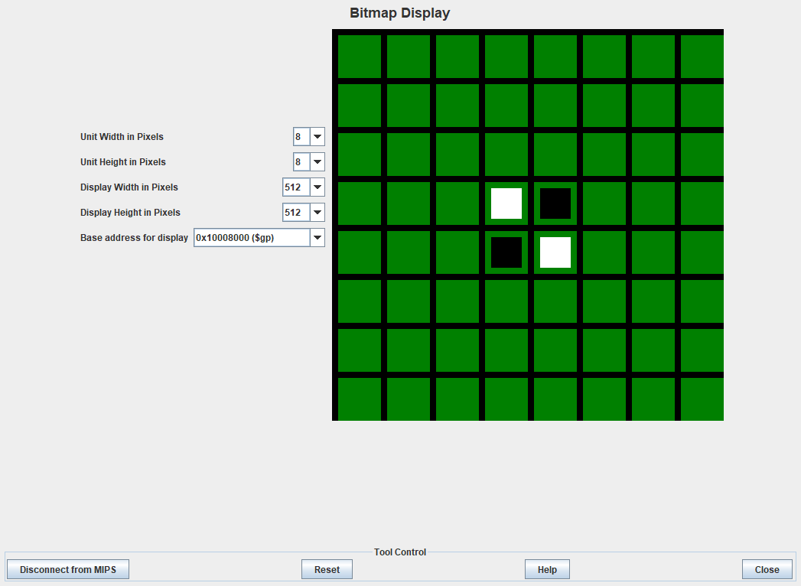

Starting Screen

Playing the game:

1. The board should be displayed with two pieces for black (Player 1) and two piece for white (Player 2)
2. Responding “Yes” to the first prompt will start single-player mode against an AI opponent
3. Responding “No” to the first prompt will start two-player mode, requiring a user input for black and white.
4. Follow the console instructions to play the game
   1. Rows / Columns range from 0 to 7, illegal inputs are not allowed and the player will be asked to re-enter the coordinates.
   2. Entering the number 10 will end the game and show final scores along with a message for the winner. **NOTE:** Entering 10 in two-player only works if the player is losing. Any other attempt to enter 10 will result as an invalid input.